**Murrieta Mesa High School**

**Spanish III Syllabus**

*¡Bienvenidos a la clase de la Lynn!*

**Class #:** H251 **Email:** [mlynn@murrieta.k12.ca.us](mailto:mlynn@murrieta.k12.ca.us) **Phone:** (951) 677-0568 ext.6251

**Prerequisite**: Grade C or better in Spanish 2 and/or teacher approval. **Materials**: Spiral Notebook per semester

**COURSE OVERVIEW**:

We have eight teachers in MVUSD that teach ASL, French and Spanish classes at MVUSD that are taught using a method called OWL ([Organic World Language](http://owlanguage.com/)), which will provide students with a 100% immersion experience! This method promotes kinesthetic, interactive learning in which the students generate the topics. OWL will be conducted primarily in a circle with students standing, moving, and interacting with everyone in the class. Students will need to be active participants in this process and will be responsible for maintain a safe and responsible environment conducive to learning. Students will be required to use ONLY **SPANISH**.

**GOALS**

* Participate and be part of a community
* To not be afraid of a second language environment
* To encourage students to experience different cultures
* To take risks and make mistakes
* Infer and use circumlocution (act it out, draw it out and use what you know)
* Use Spanish 100% of the time
* Have intrinsic motivation and student ownership

**EXPECTATIONS:**

**I expect you to give an honest effort.**  Participation is one of the most important components of learning a foreign language.  It is normal for students to feel frustrated and lost at the beginning. You need to be open to making mistakes, it is okay to be wrong, but it is not okay to quit, refuse to try, or discourage others from trying.  I will speak Spanish 100% of the time, unless there is an issue that MUST be addressed in English. It is my goal for you to **live in** SPANISH in our classroom; to think, speak, work, converse, joke, and perform in the language.

**THE ESSENTIAL (NATIONAL) STANDARDS**:

***Interpersonal Communication*** (two-way communication)- It is an exchange of information between two people or whole group. Itcan take many forms, speaking face to fact, written (in a letter, email or text)or non-verbal (facial expressions and body language)

***Interpretive Reading & Listening*** (one-way communication)-the way written or spoken language are received and interpreted.

**Presentational Writing & Speaking** (one-way communication)-the ability to present a presentation in spoken or written form on audience of listeners or readers on a variety of topics.

**GRADING**

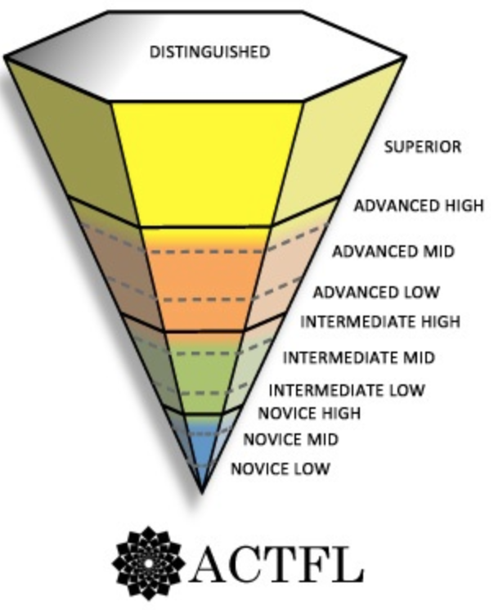This class is **PROFICIENCY** based, so activities are created to build off of what you ***CAN DO***; what you ***CAN SAY***, what you ***CAN WRITE***, and what you ***CAN UNDERSTAND*** (both verbal and written). The goal of all activities is to bring about fluency. Formative assessments are used to inform both the teacher and the student about their personal growth in fluency according to the *American Council on the Teaching of Foreign Languages* ([ACTFL)](https://www.actfl.org/about-the-american-council-the-teaching-foreign-languages/resources/language-learning-the-21st) scale and OWL principals. Summative assessments such as benchmarks will be inputted as grades on Aeries.

|  |  |  |  |  |  |  |
| --- | --- | --- | --- | --- | --- | --- |
| **Proficiency Guidelines** | Level 1 | | Level 2 | | Level 3 | |
| **1st Semester** | **2nd Semester** | **1st Semester** | **2nd Semester** | **1st Semester** | **2nd Semester** |
| Novice Low | C | D | D-/F | F | N/E | N/E |
| Novice Mid | B | C | B-/C | D | F | N/E |
| (Entering) Novice High | A | B | B | C | D | F |
| Novice High |  | A | A | B | C | D |
| (Entering) Intermediate Low |  |  |  | A | B | C |
| Intermediate  Low |  |  |  |  | A | B |
| Intermediate  Mid |  |  |  |  |  | A |
| Intermediate  High | AP Spanish or DE ASL | | | | | |
| Advance Low |

**Murrieta Mesa High School**

**Spanish 3 Syllabus for Mrs. Lynn**

*Student/Parent Agreement Form*

I have read and understood the expectations addressed in Mrs. Lynn’s Spanish III Syllabus for Murrieta Mesa High School and I am willing to abide and give my best effort.

Student Name and Period Parent/Guardian Name

Student Signature Parent/Guardian Signature

___________________________________ ____________________________________ / ___________________________

Student Email Parent/Guardian Email / Phone Number

**\*Parent/Guardian**: Please use the space below to identify any comments or concerns you may have for me. If there are any special circumstances I should be aware of in regard to your child, please identify them here.

**______________________________________________________________________________________________________________________________________________________________________________________________________________________________________________________________________________**

Consent to be Recorded and Watch Videos and Movies in Class

Dear Parents/Guardians,

Please be advised that your child may be recorded to show best teaching practices for the World Language Department at Murrieta Mesa High School. The videos will only be viewed by other staff members of Murrieta Valley Unified School District. I Consent. I do not consent

From time to time videos and movies (G, PG, and PG 13) will be shown in class to enhance Spanish acquisition. I Consent. I do not consent